Project Design Phase
Solution Architecture

Date | 7 October 2026
Team ID
Project Name | Script-Controlled ACL – Restrict Record Access Based on Field Value
Maximum Marks | 4 Marks

Solution Architecture:
Solution architecture is a complex process – with many sub-processes – that bridges the gap between business problems and technology solutions. Its goals are to:
- Find the best tech solution to solve existing business problems.
- Describe the structure, characteristics, behavior, and other aspects of the software to project stakeholders.
- Define features, development phases, and solution requirements.
- Provide specifications according to which the solution is defined, managed, and delivered.
Example - Solution Architecture Diagram: Script-Controlled ACL – Restrict Record Access Based on Field Value
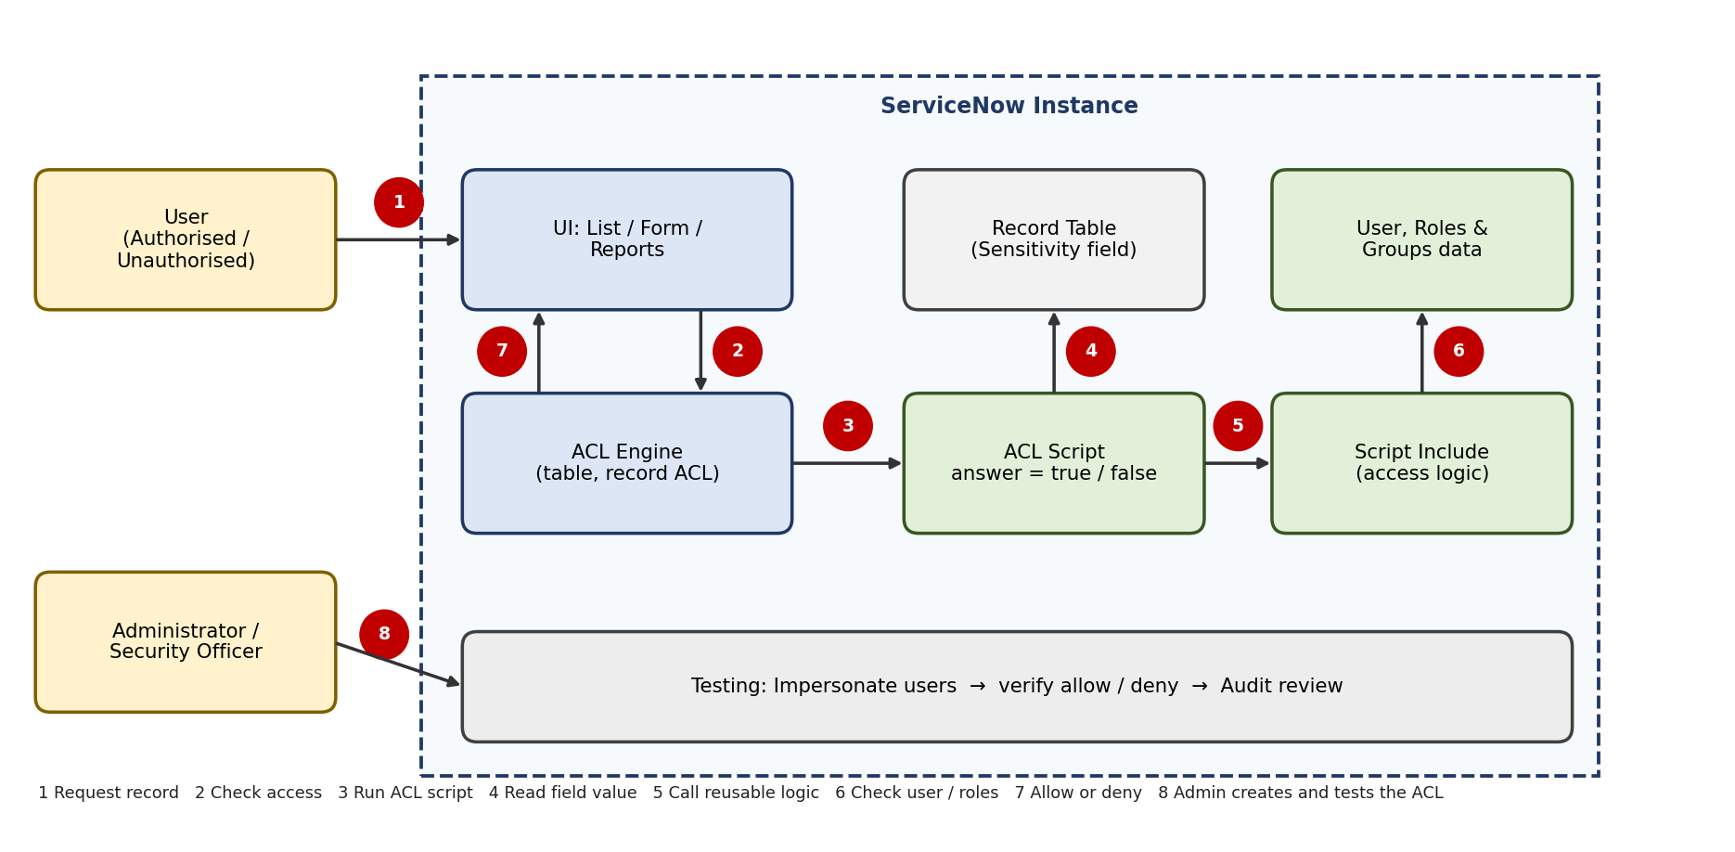
Figure 1: Architecture and data flow of the script-controlled ACL for restricting record access
Reference: https://www.servicenow.com/docs/r/application-development/servicenow-sdk/acl-api-now-ts.html

